«Receipt_Date» **Official Receipt for Income Tax Purposes**

«Name_Part_1» «Name_Part_2»

«Address_Line_1»

«Address_Line_2»

«Address_Line_3»

«City» «State_Or_Province» «ZipPostal_Code»

Thank you for your important gift to United Way. Your formal receipt for income tax purposes is below.

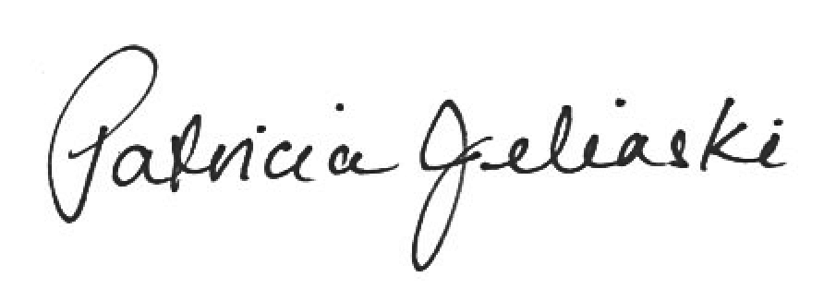Sincerely,

Patricia Jelinski

Chief Executive Officer

|  |  |  |  |
| --- | --- | --- | --- |
|  |  |  |  |
| Donation Date: | «Last_Receipt_Selection_Date» | Receipt No: | «Issued_Receipt_Number» |
| Date Receipt Issued: | «Receipt_Date» | Amount: | «Receipt_Amount» |
|  |  | Our ref: | «Individual_Account» |
|  |  |  |  |
| «Name_Part_1» «Name_Part_2» «Address_Line_1»  «Address_Line_2»  «Address_Line_3»  «City» «State_Or_Province» «ZipPostal_Code» | | |  |
|  |
| 201 - 633 Courtney St, Victoria BC V8W 1B9 | t 250 385 6708 | w uwgv.ca | | | YOUR FILE COPY |

|  |  |  |  |
| --- | --- | --- | --- |
| LH-Logo-GS.jpg | 201 - 633 Courtney St  Victoria BC V8W 1B9  t 250 385 6708  w uwgv.ca | **Official Receipt for Income Tax Purposes**  Thank You! United Way is focused on the following community impact areas: All that kids can be,  From poverty to possibility, Strong communities. | |
| Donation Date: | «Last_Receipt_Selection_Date» | Receipt No: | «Issued_Receipt_Number» |
| Date Receipt Issued: | «Receipt_Date» | Amount: | «Receipt_Amount» |
|  |  | Our ref: | «Individual_Account» |
|  |  |  |  |
| «Name_Part_1» «Name_Part_2»  «Address_Line_1»  «Address_Line_2»  «Address_Line_3»  «City» «State_Or_Province» «ZipPostal_Code» | | | patricia-jelinski-sig.jpg |
| **Charity BN/Registration #119278224RR0001 Canada Revenue Agency: www.cra-arc.gc.ca/charities** | | | Authorized Signature  Patricia Jelinski, Chief Executive Officer |